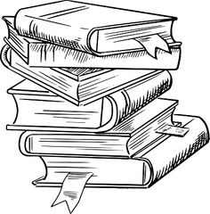

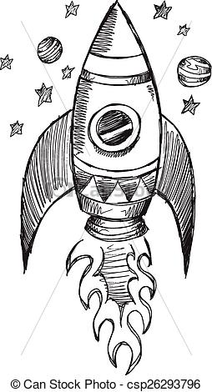
2019 Thompson Middle School Summer Reading Challenge

Welcome to the 2019 TMS summer reading challenge! This year we are participating in the Governor’s Summer Reading challenge at the state level while competing across grade levels within our school.

To participate, simply read a book over the summer and complete an entry form. Then, record the title of the book in your summer reading journal entitled A Universe of Stories.

Each grade is competing to see who can read the greatest number of books. When school starts, you simply hand in as many entry forms as you have completed to your English teacher to add to your team total. The team with the greatest number of books read will win an ice cream social. We will be collecting the forms and journals the first two weeks we return to school. So if you just want to read over the summer, you can fill them out when you return to school in August.
Summer Reading TMS 2019

Name: ___________________

Title of Book: _____________
________________________
Author: __________________
Main Character(s): __________
________________________________________________
What is the main conflict/ problem in the novel? ________
________________________________________________________________________________________________________________________________________________
What is the resolution (how does the author resolve the conflict in the end? _______________
________________________________________________________________________________________________________________________________________________
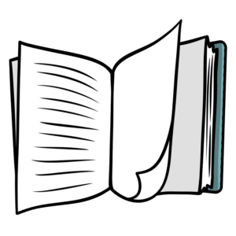
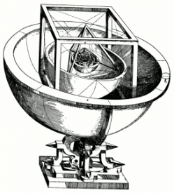
Free Bookmark

Even more Free Bookmarks
Summer Reading TMS 2019

Name: ___________________

Title of Book: _____________
_______________________
Author: __________________
Main Character(s): __________
________________________________________________
What is the main conflict/ problem in the novel? ________
________________________________________________________________________________________________________________________________________________
What is the resolution (how does the author resolve the conflict in the end? _______________
________________________________________________________________________________________________________________________________________________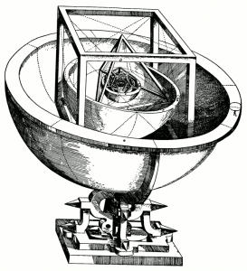

Summer Reading TMS 2019

Name: ___________________

Title of Book: _____________
________________________
Author: __________________
Main Character(s): __________
________________________________________________
What is the main conflict/ problem in the novel? ________
________________________________________________________________________________________________________________________________________________
What is the resolution (how does the author resolve the conflict in the end? _______________
________________________________________________________________________________________________________________________________________________

